1. **Alerting profile :** Normally we use default profile, if we need additional profiles we can add them according to requirement

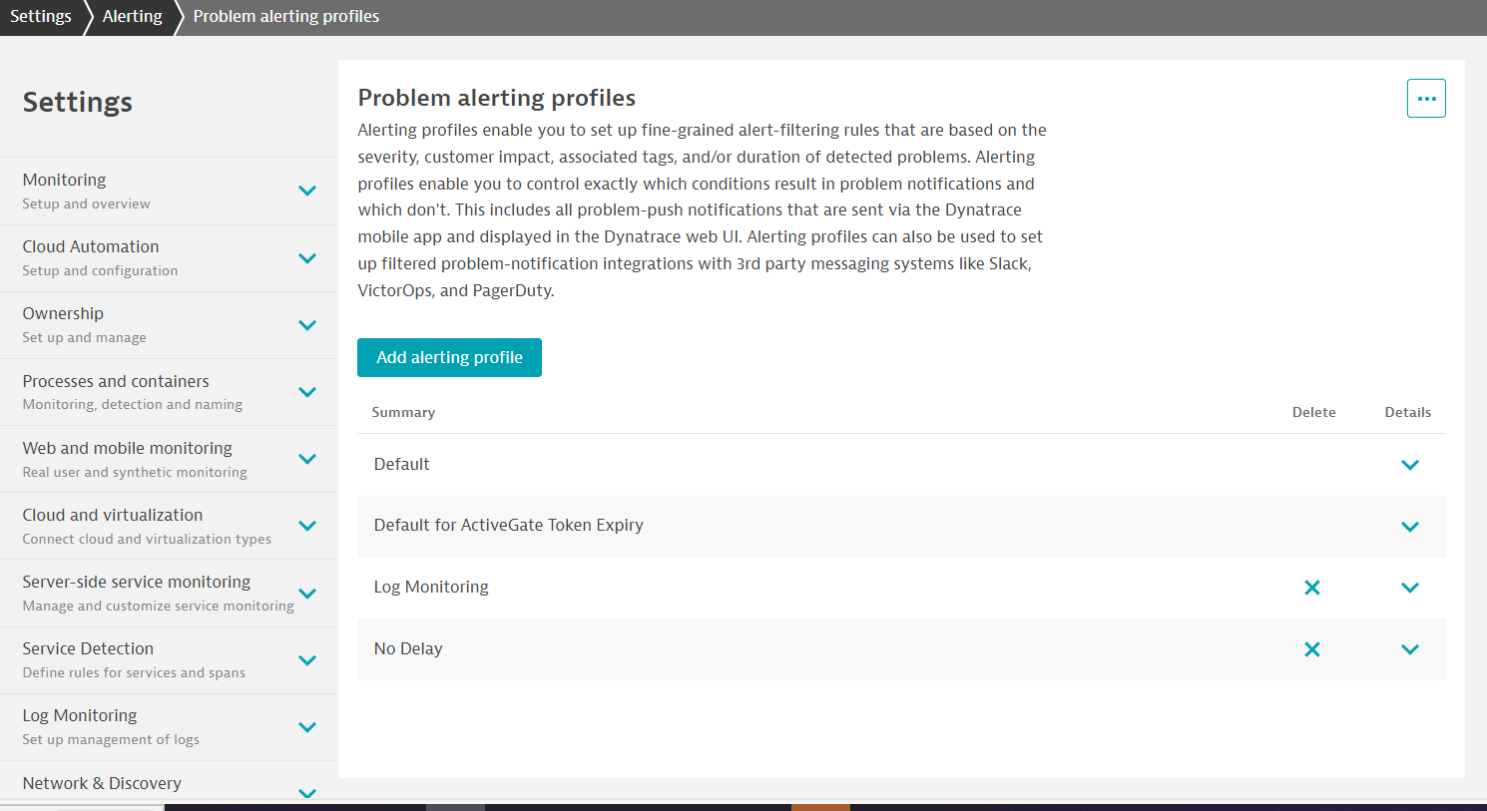

2.Integration with serviceNow:-

